Air Force Institute of Technology

Before test:

Run 10 test cases that language = "Dennis test":

Ten test cases’s is_exist are all None.

pri_dientifier and second_idendtifer are both newly added fields, so they are not used in queries for the previous database. Therefore, only the title search is active. The undate_empty_field function will add the content of these two fields only after the title search finds the target.

The etdrepo/058 has ten folder, means the copy_pdf and copy_html worked well.

AIT_ETDs has 5430 folders, means when I runed the shifter.py, this college’s records should be about 5430, right now is 4010.

Auburn University

Before test: after test:

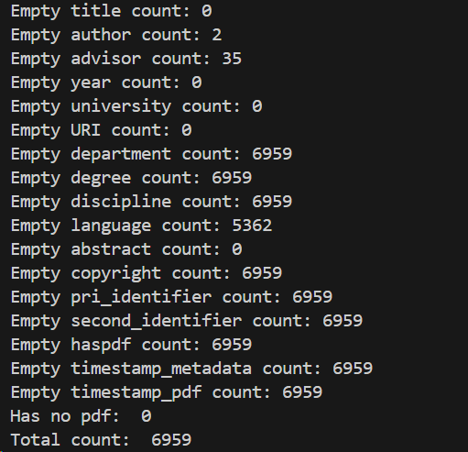

BallState

Before test:

The original code does not work, so this college has no record in MySQL.

When I was crawling the metadata, the college banned me, so I just download 700 metadata.

Copyright information needs to be extracted from the website based on different paths. Most of my code works, but after being banned, I can't access the website anymore, so there are vulnerabilities in the code. So when I run it, I'm not using the code to download the copyright.

After shifter:

Caltech

Cornell

Duke

EastCarolina

EasternMichigan

Before shifter: after shifter:

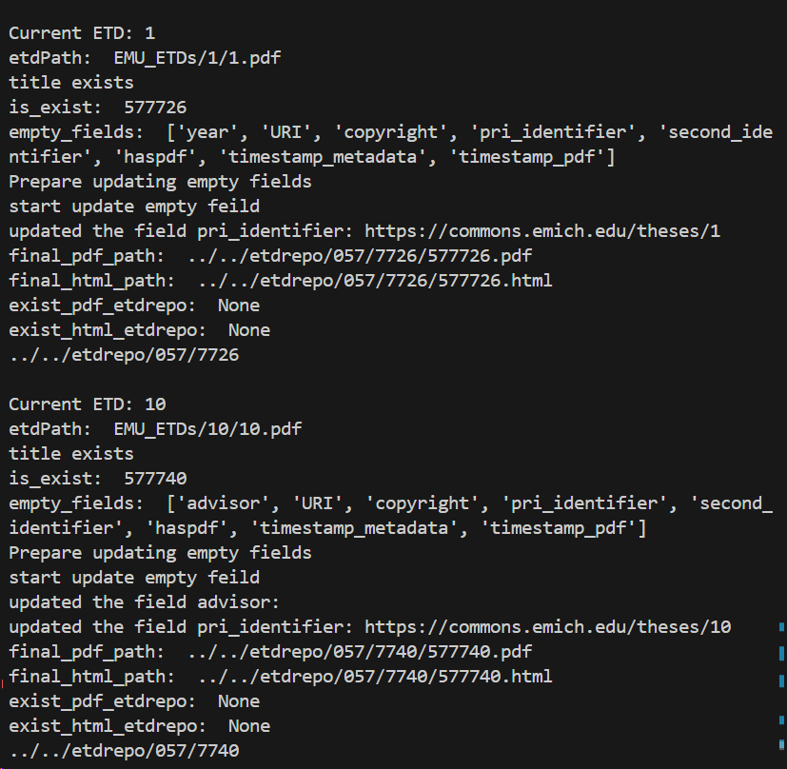

Illinois

KansasStateU

Michigan Tech

Oklahoma Universities

